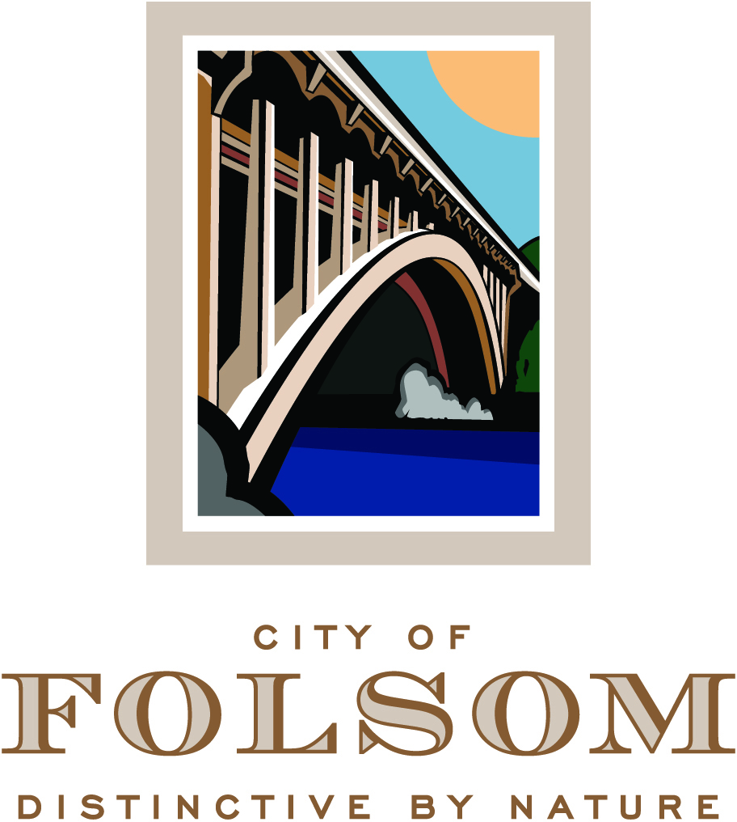

HISTORIC DISTRICT COMMISSION AGENDA

March 15, 2017
CITY COUNCIL CHAMBERS
5:00 p.m.

50 Natoma Street
Folsom, California 95630

CALL TO ORDER HISTORIC DISTRICT COMMISSION: Chair Daron Bracht, Vice Chair Candy Miller, Commissioners: John Arnaz, Mary Asay, Jeffrey Rempfer, Ross Jackson, Regina Konet

Any documents produced by the City and distributed to the Historic District Commission regarding any item on this agenda will be made available at the Community Development Counter at City Hall located at 50 Natoma Street, Folsom, California and at the table to the left as you enter the Council Chambers.

PLEDGE OF ALLEGIANCE

CITIZEN COMMUNICATION: The Historic District Commission welcomes and encourages participation in City Historic District Commission meetings, and will allow up to five minutes for expression on a non-agenda item. Matters under the jurisdiction of the Commission, and not on the posted agenda, may be addressed by the general public; however, California law prohibits the Commission from taking action on any matter which is not on the posted agenda unless it is determined to be an emergency by the Commission.

MINUTES

The minutes of March 1, 2017 will be presented for approval.

NEW BUSINESS

- PN 10-252, Leidesdorff Village Residential Project – Tentative Subdivision Map Extension, Planned Development Permit Extension, Conditional Use Permit Extension

A Public Hearing to consider a request from D & S Development for a Tentative Subdivision Map Extension, a Planned Development Permit Extension, and a Conditional Use Permit Extension for the Leidesdorff Village project. The approved Leidesdorff Village project includes development of 36 condominium units, 18 for-sale condominium flats, and 2 single-family homes. The zoning for the project site is R-4 and the General Plan designation is CA. A Mitigated Negative Declaration and Mitigation Monitoring Program were previously approved for the Leidesdorff Village project (PN 10-252) on December 9, 2014 in accordance with the California Environmental Quality Act (CEQA). (Project Planner: Principal Planner, Steve Banks / Applicant: D & S Development)

- PN 16-307, Coloma / Figueroa - Tentative Parcel Map, Garage and Patio Roof Demolition and Determination that the Project is Exempt from CEQA

A Public Hearing to consider a request from Dan Nitz for approval of a Tentative Parcel Map to subdivide an existing .483-acre residential property into three individual parcels and to demolish a 619-square-foot detached garage and 140-square-foot patio roof. The zoning designation for the site is R-2 (Two-Family Dwelling, Small Lot District) in the Figueroa Subarea of the Residential Primary Area of the Historic District and the General Plan designation is SF (Single Family). This project is categorically exempt from environmental review under Section 15315 (Minor Land Divisions) and 15301 (Existing Facilities) of the CEQA Guidelines. (Project Planner: Assistant Planner, Josh Kinkade / Applicant: Dan Nitz)

- PN 16-368, 727 Traders Lane, Escape Folsom - Conditional Use Permit and Determination that the Project is Exempt from CEQA

A Public Hearing to consider a request from Off the Hook Haunted Attractions, LLC for approval of a Conditional Use Permit for an escape room with bar and food service. The zoning designation for the site is HD (Sutter Street Subarea of the Commercial Primary Area) and the General Plan designation is CA (Specialty Commercial). This project is categorically exempt from environmental review under Section 15301 (Existing Facilities) of the CEQA Guidelines. (Project Planner: Assistant Planner, Josh Kinkade / Applicant: Off the Hook Haunted Attractions, LLC)

HISTORIC DISTRICT COMMISSION / PRINCIPAL PLANNER REPORT

The next Historic District Commission meeting is scheduled for April 5, 2017. Additional non-public hearing items may be added to the agenda; any such additions will be posted on the bulletin board in the foyer at City Hall at least 72 hours prior to the meeting. Persons having questions on any of these items can visit the Community Development Department during normal business hours (8:00 a.m. to 5:00 p.m.) at City Hall, 2nd Floor, 50 Natoma Street, Folsom, California, prior to the meeting. The phone number is 355-7222 and FAX number is 355-7274.

NOTICE REGARDING CHALLENGES TO DECISIONS
The appeal period for Historic District Commission Action: Pursuant to all applicable laws and regulations, including without limitation, California Government Code, Section 65009 and/or California Public Resources Code, Section 21177, if you wish to challenge in court any of the above decisions (regarding planning, zoning, and/or environmental decisions), you may be limited to raising only those issues you or someone else raised at the public hearing(s) described in this notice/agenda, or in written correspondence delivered to the City at, or prior to, this public hearing. Any appeal of a Historic District Commission action must be filed, in writing with the City Clerk’s Office no later than ten (10) days from the date of the action pursuant to Resolution No. 8081.

