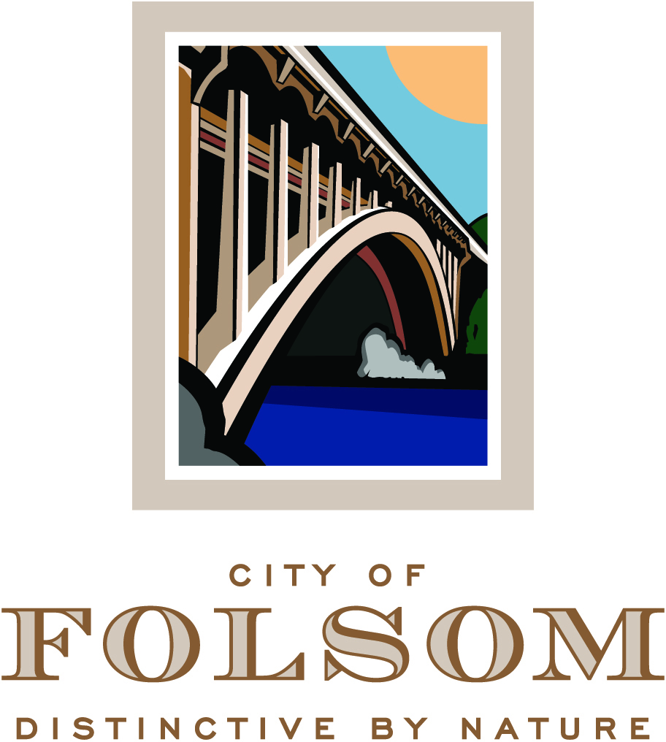

HISTORIC DISTRICT COMMISSION AGENDA

May 17, 2017
CITY COUNCIL CHAMBERS
5:00 p.m.

50 Natoma Street
Folsom, California 95630

CALL TO ORDER HISTORIC DISTRICT COMMISSION: Chair Daron Bracht, Vice Chair Candy Miller, Commissioners: John Arnaz, Mary Asay, Jeffrey Rempfer, Justin Raithel, Regina Konet

Any documents produced by the City and distributed to the Historic District Commission regarding any item on this agenda will be made available at the Community Development Counter at City Hall located at 50 Natoma Street, Folsom, California and at the table to the left as you enter the Council Chambers.

PLEDGE OF ALLEGIANCE

CITIZEN COMMUNICATION: The Historic District Commission welcomes and encourages participation in City Historic District Commission meetings, and will allow up to five minutes for expression on a non-agenda item. Matters under the jurisdiction of the Commission, and not on the posted agenda, may be addressed by the general public; however, California law prohibits the Commission from taking action on any matter which is not on the posted agenda unless it is determined to be an emergency by the Commission.

MINUTES

The minutes of April 5, 2017 will be presented for approval.

Commendation to be Presented to Mark Roberts

NEW BUSINESS

- PN 17-076, 605 Mormon Street –Residential Addition & Garage Demolition and Determination that the Project is Exempt from CEQA

A Public Hearing to consider a request from Todd Dambly for approval of an application for demolition of an existing 280-square-foot detached garage, approval of a Residential Design Review application for construction of a 1,000-square-foot two-story addition and a 181-square-foot covered porch to an existing 828-square-foot residence located at 605 Mormon Street. The zoning designation for the site is CEN/R-2 (Central Subarea of the Historic Residential Primary Area/Two-Family Residence District) and the General Plan designation is MLD (Multi- Family Low Density). This project is categorically exempt from environmental review under Section 15303 of the CEQA Guidelines (New Construction or Conversion of Small Structures). (Project Planner: Assistant Planner, Josh Kinkade / Applicant: Todd Dambly)

- PN 17-119, 507 Coloma Street - Residential Remodel and Determination that the Project is Exempt from CEQA

A Public Hearing to consider a request from AMR Construction for approval of a Design Review application for a remodel of an existing 786-square-foot residence located at 507 Coloma Street. The zoning designation for the site is NRB/C-1 (Natoma-Riley-Bidwell Commercial Primary Area of the Historic District/Neighborhood Business District Underlying Zoning) and the General Plan designation is CC (Community Commercial). This project is categorically exempt from environmental review under Section 15303 of the CEQA Guidelines (New Construction or Conversion of Small Structures). (Project Planner: Assistant Planner, Josh Kinkade / Applicant: AMR Construction)

HISTORIC DISTRICT COMMISSION / PRINCIPAL PLANNER REPORT

The next Historic District Commission meeting is scheduled for June 7, 2017. Additional non-public hearing items may be added to the agenda; any such additions will be posted on the bulletin board in the foyer at City Hall at least 72 hours prior to the meeting. Persons having questions on any of these items can visit the Community Development Department during normal business hours (8:00 a.m. to 5:00 p.m.) at City Hall, 2nd Floor, 50 Natoma Street, Folsom, California, prior to the meeting. The phone number is 355-7222 and FAX number is 355-7274.

NOTICE REGARDING CHALLENGES TO DECISIONS
The appeal period for Historic District Commission Action: Pursuant to all applicable laws and regulations, including without limitation, California Government Code, Section 65009 and/or California Public Resources Code, Section 21177, if you wish to challenge in court any of the above decisions (regarding planning, zoning, and/or environmental decisions), you may be limited to raising only those issues you or someone else raised at the public hearing(s) described in this notice/agenda, or in written correspondence delivered to the City at, or prior to, this public hearing. Any appeal of a Historic District Commission action must be filed, in writing with the City Clerk’s Office no later than ten (10) days from the date of the action pursuant to Resolution No. 8081.

