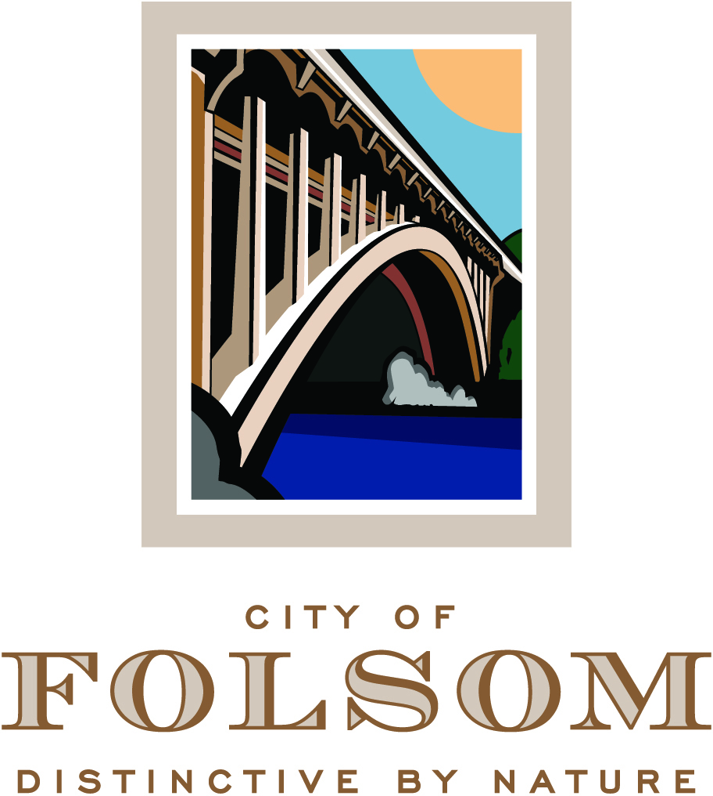

HISTORIC DISTRICT COMMISSION AGENDA

August 16, 2017
CITY COUNCIL CHAMBERS
5:00 p.m.

50 Natoma Street
Folsom, California 95630

CALL TO ORDER HISTORIC DISTRICT COMMISSION: Vice Chair Candy Miller, Justin Raithel, Jeffrey Rempfer , John Arnaz, Mary Asay, Regina Konet, Chair Daron Bracht

Any documents produced by the City and distributed to the Historic District Commission regarding any item on this agenda will be made available at the Community Development Counter at City Hall located at 50 Natoma Street, Folsom, California and at the table to the left as you enter the Council Chambers.

PLEDGE OF ALLEGIANCE

CITIZEN COMMUNICATION: The Historic District Commission welcomes and encourages participation in City Historic District Commission meetings, and will allow up to five minutes for expression on a non-agenda item. Matters under the jurisdiction of the Commission, and not on the posted agenda, may be addressed by the general public; however, California law prohibits the Commission from taking action on any matter which is not on the posted agenda unless it is determined to be an emergency by the Commission.

MINUTES

The minutes of August 2, 2017 will be presented for approval.

INFORMATIONAL ITEMS

- Lake Natoma Gap Closure

The Lake Natoma Gap Closure project is a city council-authorized, Class IV, separated bikeway that will be constructed parallel to Leidesdorff Street. On the west end, it will extend from the American River Parkway trail access point (near the Leidesdorff Lid) to the intersection of Scott Street and Riley Street on the east end, completing the off-street bicycle route around Lake Natoma. Additional minor pedestrian and traffic safety improvements are included in the project to improve circulation in the Historic District. Construction is anticipated to begin in winter/early spring 2018. (Presenter: Director of Parks & Recreation, Robert Goss)

NEW BUSINESS

- PN 17-204, Community Bible Church Campus Remodel - Commercial Design Review and Determination that the Project is Exempt from CEQA

A Public Hearing to consider a request from Rich Burrill for approval of a Commercial Design Review application for a remodel of the existing buildings of the Community Bible Church campus, located at 611 Riley Street, 610-612 Persifer Street, and 601 Natoma Street. The zoning classifications for the project are R-1-M/CEN (Single-Family Residential- Small Lot District/Central Subarea of the Historic Residential Primary Area) and BP/NRB (Business Professional District/Natoma Riley Bidwell Commercial Primary Area of the Historic District), and the General Plan land use designations are CC (Community Commercial) and SF (Single Family). This project is categorically exempt from environmental review under Section 15301 of the CEQA Guidelines (Existing Facilities). (Project Planner: Assistant Planner, Josh Kinkade / Applicant: Rich Burrill)

PRINCIPAL PLANNER REPORT

The next Historic District Commission meeting is scheduled for September 6, 2017. Additional non-public hearing items may be added to the agenda; any such additions will be posted on the bulletin board in the foyer at City Hall at least 72 hours prior to the meeting. Persons having questions on any of these items can visit the Community Development Department during normal business hours (8:00 a.m. to 5:00 p.m.) at City Hall, 2nd Floor, 50 Natoma Street, Folsom, California, prior to the meeting. The phone number is 355-7222 and FAX number is 355-7274.

NOTICE REGARDING CHALLENGES TO DECISIONS
The appeal period for Historic District Commission Action: Pursuant to all applicable laws and regulations, including without limitation, California Government Code, Section 65009 and/or California Public Resources Code, Section 21177, if you wish to challenge in court any of the above decisions (regarding planning, zoning, and/or environmental decisions), you may be limited to raising only those issues you or someone else raised at the public hearing(s) described in this notice/agenda, or in written correspondence delivered to the City at, or prior to, this public hearing. Any appeal of a Historic District Commission action must be filed, in writing with the City Clerk’s Office no later than ten (10) days from the date of the action pursuant to Resolution No. 8081.

