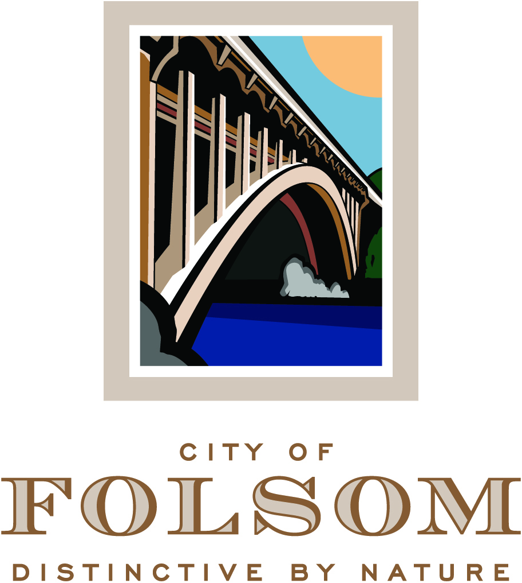

HISTORIC DISTRICT COMMISSION AGENDA

November 15, 2017
CITY COUNCIL CHAMBERS
5:00 p.m.

50 Natoma Street
Folsom, California 95630

CALL TO ORDER HISTORIC DISTRICT COMMISSION: Justin Raithel, Jeffrey Rempfer, John Arnaz, Mary Asay, Regina Konet, Vice Chair Candy Miller, Chair Daron Bracht

Any documents produced by the City and distributed to the Historic District Commission regarding any item on this agenda will be made available at the Community Development Counter at City Hall located at 50 Natoma Street, Folsom, California and at the table to the left as you enter the Council Chambers.

PLEDGE OF ALLEGIANCE

CITIZEN COMMUNICATION: The Historic District Commission welcomes and encourages participation in City Historic District Commission meetings, and will allow up to five minutes for expression on a non-agenda item. Matters under the jurisdiction of the Commission, and not on the posted agenda, may be addressed by the general public; however, California law prohibits the Commission from taking action on any matter which is not on the posted agenda unless it is determined to be an emergency by the Commission.

MINUTES

The minutes of September 6, 2017 will be presented for approval.

INFORMATIONAL ITEMS

- Southern Pacific Depot Grounds Temporary Restroom Building Located at 200 Wool Street

The City of Folsom is providing a temporary restroom to be on the Southern Pacific Depot grounds at 200 Wool Street (within the Sutter Street Commercial Primary Area of the Historic District) to serve the Historic District until the Sutter Row building is constructed with permanent restrooms. (Project Planner: Assistant Planner, Josh Kinkade)

NEW BUSINESS

- PN 17-345, 310 Figueroa Street - Residential Design Review and Determination that the Project is Exempt from CEQA

A Public Hearing to consider a request from Ron & Tina Edwards for approval of design review application for a 2,296-square-foot two-story single family residence located at 310 Figueroa Street. The zoning designation for the site is FIG/R-2 (The Figueroa Subarea of the Historic Residential Primary Area/Two Family Residence District) and the General Plan designation is SF (Single-Family). This project is categorically exempt from environmental review under Section 15303 of the CEQA Guidelines (New Construction or Conversion of Small Structures). (Project Planner: Assistant Planner, Josh Kinkade / Applicant: Ron & Tina Edwards)

PRINCIPAL PLANNER REPORT

The next Historic District Commission meeting is scheduled for December 6, 2017. Additional non-public hearing items may be added to the agenda; any such additions will be posted on the bulletin board in the foyer at City Hall at least 72 hours prior to the meeting. Persons having questions on any of these items can visit the Community Development Department during normal business hours (8:00 a.m. to 5:00 p.m.) at City Hall, 2nd Floor, 50 Natoma Street, Folsom, California, prior to the meeting. The phone number is 355-7222 and FAX number is 355-7274.

NOTICE REGARDING CHALLENGES TO DECISIONS
The appeal period for Historic District Commission Action: Pursuant to all applicable laws and regulations, including without limitation, California Government Code, Section 65009 and/or California Public Resources Code, Section 21177, if you wish to challenge in court any of the above decisions (regarding planning, zoning, and/or environmental decisions), you may be limited to raising only those issues you or someone else raised at the public hearing(s) described in this notice/agenda, or in written correspondence delivered to the City at, or prior to, this public hearing. Any appeal of a Historic District Commission action must be filed, in writing with the City Clerk’s Office no later than ten (10) days from the date of the action pursuant to Resolution No. 8081.

