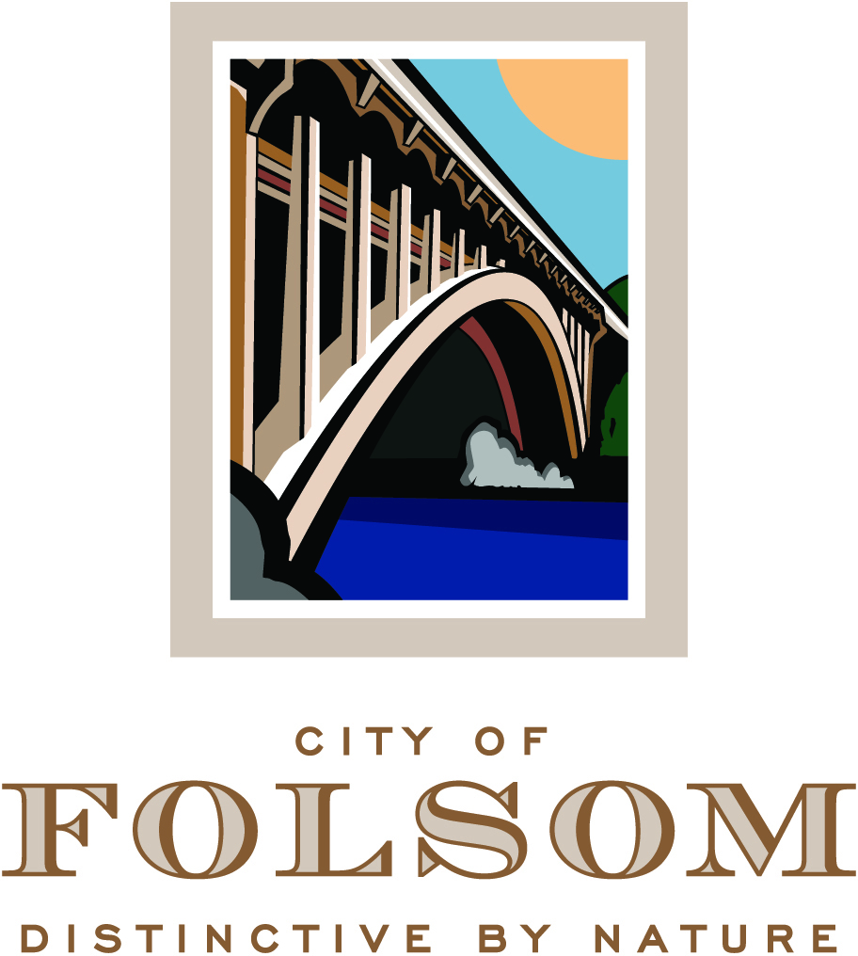

HISTORIC DISTRICT COMMISSION AGENDA

July 6, 2016
CITY COUNCIL CHAMBERS
5:00 p.m.

50 Natoma Street
Folsom, California 95630

CALL TO ORDER HISTORIC DISTRICT COMMISSION: Chair Daron Bracht, Vice Chair Candy Miller, Commissioners: John Arnaz, Mary Asay, Jeffrey Rempfer, Mark Roberts, Ross Jackson

Any documents produced by the City and distributed to the Historic District Commission regarding any item on this agenda will be made available at the Community Development Counter at City Hall located at 50 Natoma Street, Folsom, California and at the table to the left as you enter the Council Chambers.

PLEDGE OF ALLEGIANCE

CITIZEN COMMUNICATION: The Historic District Commission welcomes and encourages participation in City Historic District Commission meetings, and will allow up to five minutes for expression on a non-agenda item. Matters under the jurisdiction of the Commission, and not on the posted agenda, may be addressed by the general public; however, California law prohibits the Commission from taking action on any matter which is not on the posted agenda unless it is determined to be an emergency by the Commission.

MINUTES: The minutes of June 1, 2016 stand approved unless there are corrections.

NEW BUSINESS

- PN 16-109, 409 Natoma Street – Remodel and Enclosure Commercial Design Review, Determination that the Project is Exempt from CEQA

Request for Commercial Design Review Approval for an enclosure of a 712-square-foot covered patio area and remodel of an existing 4,296-square-foot restaurant at 409 Natoma Street. Zoning for this project is Neighborhood Business District/ Natoma-Riley-Bidwell Commercial Primary Area of the Historic District (C-1/NRB). The project is categorically exempt under Section 15301 (Existing Facilities) of the California Environmental Quality Act (CEQA). (Project Planner: Assistant Planner, Josh Kinkade / Applicant: Robert Lin & Brissa A. Galvanleon

REPORTS

Historic District Commission/Principal Planner:

The next Historic District Commission meeting is scheduled for July 20, 2016. Additional non-public hearing items may be added to the agenda; any such additions will be posted on the bulletin board in the foyer at City Hall at least 72 hours prior to the meeting. Persons having questions on any of these items can visit the Community Development Department during normal business hours (8:00 a.m. to 5:00 p.m.) at City Hall, 2nd Floor, 50 Natoma Street, Folsom, California, prior to the meeting. The phone number is 355-7222 and FAX number is 355-7274.

NOTICE REGARDING CHALLENGES TO DECISIONS
The appeal period for Historic District Commission Action: Pursuant to all applicable laws and regulations, including without limitation, California Government Code, Section 65009 and/or California Public Resources Code, Section 21177, if you wish to challenge in court any of the above decisions (regarding planning, zoning, and/or environmental decisions), you may be limited to raising only those issues you or someone else raised at the public hearing(s) described in this notice/agenda, or in written correspondence delivered to the City at, or prior to, this public hearing. Any appeal of a Historic District Commission action must be filed, in writing with the City Clerk’s Office no later than ten (10) days from the date of the action pursuant to Resolution No. 8081.

